A project

PowerPuff Quest


CSE 100: Software Development Project I

SUBMITTED BY

Name | ID | Intake/section
Rezowana Hossain | 20254103252 | 56/07
Rubaba Binte Mahbub | 20254103260 | 56/07
Mehreen Bintay Yousuf Simy | 20254103266 | 56/07

S U P E R V I S E D B Y:

Mastura Sadaf
Lecturer, Department of CSE
BUBT

DEPARTMENT OF COMPUTER SCIENCE AND ENGINEERING BANGLADESH UNIVERSITY OF BUSINESS AND TECHNOLOGY (BUBT)

20th, August, 2026

Abstract

The PowerPuff Quest game is a role playing game that you can play on your computer. It is made using the C programming language. This game has a lot of features like signing up and logging in. The PowerPuff Quest game also has a battle system that is inspired by the Powerpuff Girls.

You get to choose which Powerpuff Girl you want to be. Blossom, Bubbles or Buttercup. Each Powerpuff Girl has her strengths and weaknesses. You have to fight against five guys who get tougher and tougher.

In the PowerPuff Quest game you take turns doing things like attacking the guys healing yourself or using special powers that you unlock. The PowerPuff Quest game also tells you when you are low on health and needs to rest. There are areas where you can rest and get better. The Powerpuff Girls even talk to each other in the game. The game is very colorful and fun to play.

The PowerPuff Quest game also saves your progress automatically so you can play again later. The PowerPuff Quest game stores your user name and password. How far you have gotten in the game on your own computer. This way you can keep playing the PowerPuff Quest game whenever you want.

The person who made the PowerPuff Quest game used a lot of C programming concepts, like functions and arrays and strings and file handling. They also used statements and loops and made sure that the user puts in the right information. The PowerPuff Quest game is an example of how to make a simple game using C.

List of Figures

Sl.No. | Figure Name | Page
1 | Main Menu of PowerPuff Quest | 19
2 | User Registration Interface | 19
3 | User Login Interface | 20
4 | Character Selection Screen | 21
5 | Initial Team Dialogue | 21
6 | Battle Screen and Player Options | 22
7 | Health Warning and Healing System | 22
8 | Special Skill Selection Interface | 23
9 | Rest Area and Save Point | 23
10 | Game Progress Save and Resume Feature | 24
11 | Level Completion and Skill Absorption | 24
12 | Game Over Screen | 25
13 | Final Victory Screen | 25

Table of Contents

Abstract i
List of Figures ii
Chapter: 1 | Introduction 1-3
  - Problem Specification/Statement
  - Objectives
  - Flow of the Project
  - Organization Of Project Report
Chapter: 2 | Background 4-6
  - Existing System Analysis
  - Supporting Literatures
Chapter: 3 | System Analysis & Design 7-15
  - Technology & Tools
  - Model & Diagram
    - Model (SDLC/Agile/Waterfall/OOM)
    - Use Case Diagram
    - Context Level Diagram
    - Data Flow Diagram
    - Database Schema
    - Algorithms/Flowchart
Chapter: 4 | Implementation 16-18
  - Interface Design/Front-End
  - Back-End
  - Modules
Chapter: 5 | User Manual 19-25
  - System Requirement
    - Hardware Requirement
    - Software Requirement
  - User Interfaces
    - Panel A
    - Panel B
5.2.3. Login Credentials
Chapter: 6 | Conclusion 25-26
  - Conclusion
  - Limitation
  - Future Works
References 27
Appendix A 28

Chapter 1 INTRODUCTION

Problem Specification
Computer games are an effective way to practice programming because they combine input processing, decision-making, data storage, and user feedback in a single application. PowerPuff Quest is a compact console game designed around these ideas. It lets a registered player lead a selected Powerpuff Girl through a sequence of battles against fictional villains in order to save Townsville.

Objectives
- Develop a menu-driven C application with user registration and login.
- Provide three playable characters with different health and attack values.
- Implement turn-based battles against five opponents with increasing strength.
- Add healing, special skills, warnings, rest areas, and level rewards to create strategy.
- Save incomplete game progress and allow the same authenticated user to resume it.
- Apply safe integer input validation to avoid infinite input loops and crashes.

Scope
PowerPuff Quest is a C-based console role-playing game designed for educational and entertainment purposes. Its scope includes:
- User registration and login using local text files.
- Character selection among Blossom, Bubbles, and Buttercup.
- Turn-based battles against five predefined villains.
- Player actions: normal attack, healing, special-skill use, and save-and-quit.
- Health, attack power, enemy strength, and skill-progression management.
- Automatic game saving and resuming for the logged-in user.
- Input validation to prevent invalid numeric entries from crashing the program.
- Colorful console messages, character dialogues, rest areas, victory, and game-over screens.
- Local storage through users.txt and savegame.txt.
The project does not include online multiplayer, graphical animation, sound effects, encrypted passwords, databases, leaderboards, or mobile/web support.

Organization Of Project Report

Chapter 1 introduces the project, its problem, objectives, and report structure. Chapter 2 discusses the background and comparable systems. Chapter 3 presents the analysis and design models. Chapter 4 explains implementation choices and modules. Chapter 5 provides operating instructions and interface guidance. Chapter 6 concludes the report, identifies limitations, and suggests future improvements. The appendix contains selected source-code information.

Chapter 2 BACKGROUND

Existing System Analysis
Traditional small console games commonly begin immediately without user identity, use fixed character statistics, and lose all progress when the program exits. Such systems are simple to build but offer limited personalization and replay value. They also often assume that users will always enter correct numeric input. In practice, invalid input can cause repeated scanning failures or confuse the player.

PowerPuff Quest improves on this model by separating authentication from gameplay and by storing user and game information in files. The getValidInt() helper function repeatedly asks for a valid number, while clearInputBuffer() removes incorrect characters remaining in the input stream. The game records the current user, level, health, maximum health, attack, unlocked skill count, and character selection. This makes the program more robust than a one-session-only game.
Aspect | Typical basic console game | PowerPuff Quest
Access | Starts without identity | Register and login workflow
Progress | Lost at exit | Saved game can be resumed
Input | May fail on non-numeric values | Validated integer input
Gameplay | Single repeated action | Attack, heal, skills, rest areas
Feedback | Minimal text output | Color-coded messages and warnings

Supporting Literatures

The project follows established introductory programming concepts. Structured programming recommends decomposing a complex task into focused functions, as applied through functions for registration, login, saving, loading, dialogue, rest areas, and game control. File input/output is used to preserve data beyond program execution. Arrays hold the fixed lists of monsters, monster statistics, colors, and skills; strings represent usernames, passwords, and display labels.
Game-design literature also recognizes feedback, incremental difficulty, rewards, and recoverable checkpoints as important components of player engagement. The program uses stronger monsters in later levels, attack increases after victories, skills as rewards, health-restoration areas, and warning messages when the player's health is low. These features make the project suitable as both a programming exercise and a simple interactive game
Chapter 3

SYSTEM ANALYSIS & DESIGN

Technology & Tools

Technology/Tool | Purpose in the project
C programming language | Implements program logic, functions, arrays, and control flow.
Standard input/output library (stdio.h) | Supports console display, keyboard input, and file operations.
String library (string.h) | Compares and copies usernames, passwords, and skill names.
Standard library (stdlib.h) | Provides general utility support used by the program.
Text files | users.txt stores account records; savegame.txt stores current game state.
C compiler / IDE | Compiles and executes the source code, for example GCC, Code::Blocks, or VS Code.

Model & Diagram

Model (SDLC/Agile/Waterfall/OOM)
A simplified Waterfall model is appropriate because the project has a stable and limited scope. The requirements were identified first, followed by design of the menus, files, battles, and functions. The design was then implemented in C and tested with valid and invalid user input. The resulting sequence is requirements analysis, system design, coding, testing, and maintenance.

Requirements --> Design --> Implementation --> Testing --> Maintenance

| | | |

user needs diagrams C source test cases

System Architecture
The PowerPuff Quest system follows a simple layered component architecture. The player interacts with the console interface, which sends choices to the application logic. The application logic manages authentication, gameplay, input validation, saving, loading, and game results. Local text files store user credentials and saved game data.
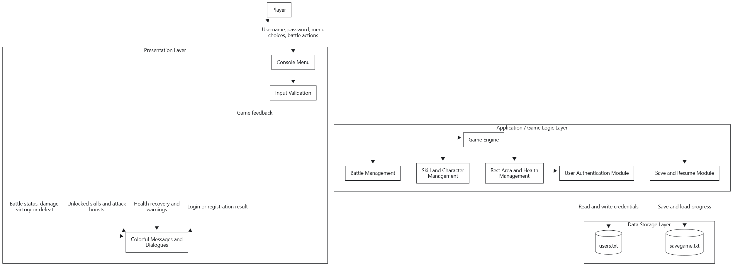

Component | Responsibility
Player | Provides login details, character selection, and gameplay actions.
Console Interface | Displays menus, battle information, dialogue, warnings, and results.
Input Validation | Ensures numeric menu choices are valid and prevents input-loop errors.
Authentication Module | Registers users, checks duplicate usernames, and verifies login credentials.
Game Engine | Controls levels, game flow, character selection, and final game conditions.
Battle Management | Processes attack, healing, monster counterattacks, and defeat conditions.
Skill Management | Unlocks skills after victories and increases the player’s attack power.
Save and Resume Module | Saves and restores the current user’s level, HP, attack, skills, and character.
users.txt | Stores registered usernames and passwords.
savegame.txt | Stores the current unfinished game state.

Use Case Diagram
The primary actor is the Player. The player may register, log in, start a new game, resume a saved game, choose a character, battle monsters, heal, use skills, save and quit, log out, or exit the application.
[Player]
|-- Register account
|-- Login
|-- Start new game / Resume saved game
|-- Choose character
|-- Attack, heal, or use skill
|-- Save and quit
|-- Logout / Exit

Context Level Diagram
At context level, the Player provides credentials and gameplay choices to the PowerPuff Quest system. The system returns menus, validation messages, battle status, and results. The system also exchanges account information with users.txt and progress information with savegame.txt.

Player <--> PowerPuff Quest System <--> users.txt

|

+--------------------> savegame.txt

Data Flow Diagram
The level-1 data flow has four main processes: account management, game initialization, battle processing, and save management. Account management reads or writes user records. Game initialization collects a character choice or existing saved state. Battle processing changes health, enemy health, attack, and skills. Save management writes or reads the active session state.

Credentials --> [1. Account Management] <--> users.txt

Choice ------> [2. Game Initialization] <--> savegame.txt

Action ------> [3. Battle Processing] ----> Battle result

State ------- > [4. Save Management] <----> savegame.txt
    - Database Schema
File / Entity | Fields
User record (users.txt) | username, password
Saved game record (savegame.txt) | username, level, hp, maxHP, attack, unlockedSkillsCount, characterChoice
Runtime game data | monsterName, monsterHP, monsterAttack, skillName, acquiredSkills
The project uses flat text files rather than a relational database. The following logical schema descri

Algorithms/Flowchart

The main algorithm validates the menu choice, runs the selected process, and returns to the appropriate menu. The battle algorithm repeats until either the player or the current monster has no health remaining.
Start
|
Display menu -> Register/Login -> Start or Resume game
| |
| Select action
| |
| Update monster/player health
| |
+<-- Save/Quit <--- Defeat? -- No --- Repeat
|
Yes -> reward / next level / victory

Chapter 4

IMPLEMENTATION

Interface/Front-End Design
The front-end is a terminal-based interface. It uses clearly numbered menu choices and ANSI color macros to distinguish information: cyan for prompts, yellow for choices and hints, green for success, red for errors, and character-specific colors for dialogue. This makes the console output easier to scan without requiring a graphical user interface.

The interface changes according to the user state. Before login, the user sees registration or login options. After login, the user sees start, resume, logout, and exit options. During combat, the player sees current health, enemy health, attack value, available moves, and warnings. The skill option appears only after a skill has been acquired.

Interface/Front-End Design
The front end of PowerPuff Quest is a console-based user interface developed using C language. It provides a simple, menu-driven interaction system where the user enters choices through the keyboard and receives immediate feedback on the screen.
The interface uses ANSI color codes to make the game more attractive and understandable. Different colors are used for menus, instructions, successful messages, warnings, errors, character dialogue, and battle results. For example, green indicates success, red indicates errors or danger, yellow displays options and hints, and cyan is used for user-input prompts.
The front end contains the following screens:
- Main menu for registration, login, and exit.
- Login and registration panels for user authentication.
- Post-login menu for starting a new game, resuming a saved game, logging out, or exiting.
- Character-selection panel for Blossom, Bubbles, and Buttercup.
- Battle screen showing player HP, monster HP, attack power, and available actions.
- Skill-selection panel for choosing unlocked special skills.
- Rest-area panel for health recovery and game progress information.
- Game-over and victory screens for final game results.
The design is user-friendly because all options are numbered, instructions are displayed before each action, and invalid input is handled safely. The system also gives health warnings when the player’s HP becomes low, helping the player make better decisions during battle.

Modules/Feature

Module | Main responsibility | Related functions
Input validation | Accept correct numeric choices and discard invalid input. | getValidInt(), clearInputBuffer()
User management | Register users, prevent duplicates, and authenticate users. | hasAnyUsers(), isUserExists(), registerUser(), loginUser()
Save management | Store, restore, and remove session state. | saveGameState(), loadGameState(), deleteSaveState()
Game engine | Run the character selection, levels, combat, rewards, and ending. | startPowerPuff_Quest()
Presentation | Display team story content and recovery information. | teamDialogue(), restArea()

Chapter 5

USER MANUAL

System Requirement
    - Hardware Requirement
- Processor: Any standard desktop or laptop processor capable of running a C compiler.
- Memory: 256 MB RAM or higher; the application itself uses very little memory.
- Storage: At least 10 MB free space for source code, executable file, and text data files.
- Input/output: Keyboard and a terminal or command prompt window.

Software Requirement
- Operating system: Windows, Linux, or macOS with a compatible terminal.
- Compiler: GCC, MinGW, Code::Blocks compiler, or another ANSI C-compatible compiler.
- Libraries: Standard C libraries stdio.h, string.h, and stdlib.h.
- Runtime files: users.txt and savegame.txt are created in the program working directory as needed

User Interfaces
    - Panel A
The opening panel allows a new user to register or an existing user to log in.
- Register a new account
- Log in with an existing account
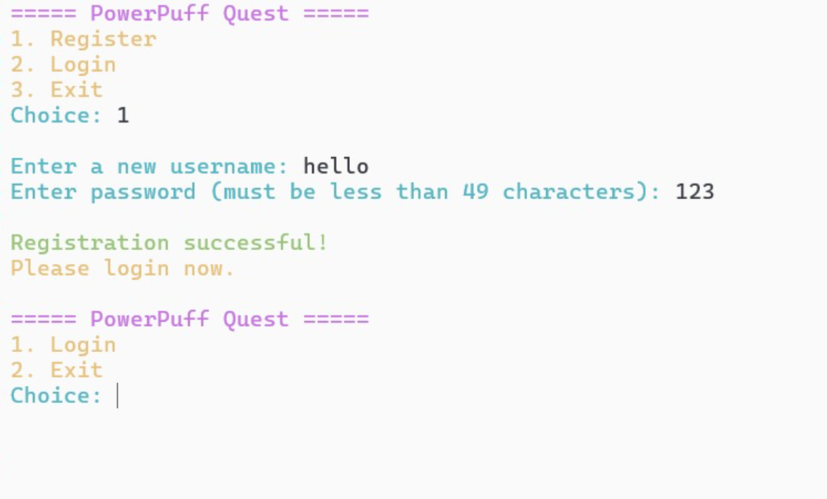
- Exit the application
    - Panel B
After successful login, the dashboard displays the logged-in username and provides game options:
- Start New Game
- Resume Saved Game (shown only when a saved game exists)
- Logout
- Exit Game

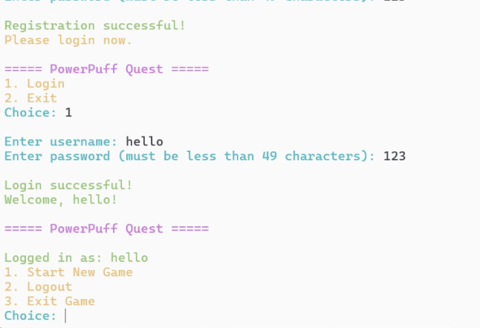

    - Continue…
When starting a new game, the player selects one Powerpuff Girl:
- Blossom — Balanced: HP 120, Attack 20
- Bubbles — Tank/Healer: HP 140, Attack 15
- Buttercup — Berserker: HP 100, Attack 25
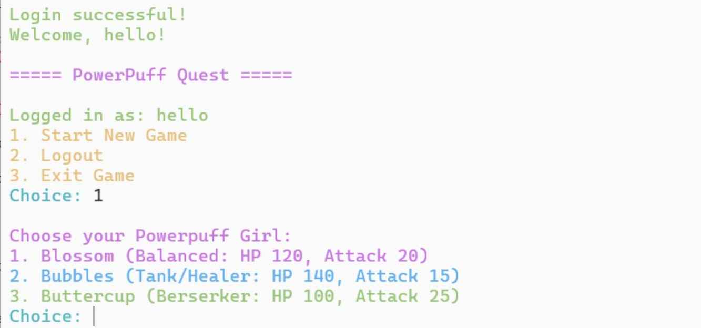

    - Login Credentials

Each level shows the current monster, its HP and attack value, the player’s HP and attack value, and available actions:
- Normal Attack
- Heal (+20 HP)
- Use Special Skill (after a skill is unlocked)
- Save and Exit
The interface also provides low-health warnings, battle results, level-completion messages, and newly unlocked skills.
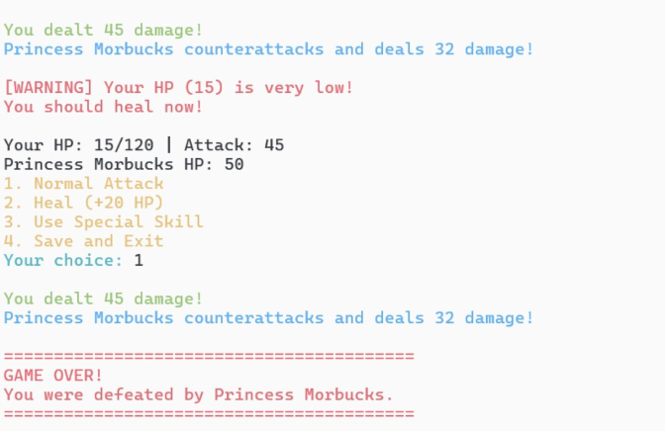

Chapter 6

CONCLUSION

Conclusion
PowerPuff Quest successfully demonstrates how a complete, menu-driven game can be built with fundamental C programming techniques. The project integrates authentication, text-file storage, battle mechanics, health management, skills, progression, and input validation into a single application. Its main strength is that each feature has a clear programming purpose while also contributing to a playable user experience. The save-and-resume feature particularly improves usability by allowing a player to continue an unfinished game session.

Limitations
- Passwords are stored as plain text and should not be used for real security-sensitive accounts.
- Only one save record is maintained in savegame.txt, which limits multi-user simultaneous save support.
- The game has a fixed set of five monsters, three characters, and predetermined skills.
- The console interface has no graphics, sound, mouse control, or persistent leaderboard.
- Global variables simplify the project but would be less suitable for a larger, more maintainable system.

Future Works

- Replace plain-text credentials with hashed passwords and a more secure account format.
- Create individual save files per user and support multiple save slots.
- Add experience points, inventory items, randomized enemy behavior, and more levels.
- Develop a graphical interface using a C-compatible game or GUI library.
Store data in a database and add a scoreboard or achievement system

References
- Kernighan, B. W., & Ritchie, D. M. (1988). The C Programming Language (2nd ed.). Prentice Hall.
- Deitel, P., & Deitel, H. (2016). C How to Program (8th ed.). Pearson.
- ISO/IEC. (2018). ISO/IEC 9899:2018: Programming Languages - C. International Organization for Standardization.
- GeeksforGeeks. (n.d.). C Programming Language. https://www.geeksforgeeks.org/c-programming-language/
- Tutorialspoint. (n.d.). C Programming Tutorial. https://www.tutorialspoint.com/cprogramming/
- InterviewBit. (n.d.). System Architecture: A Complete Guide. https://www.interviewbit.com/blog/system-architecture/
- PowerPuff Quest. (2026). Project source code: Console-based role-playing game developed in C. Unpublished project source code.

Appendix A
The appendix summarizes the primary functions included in the project source code.
Function | Description
clearInputBuffer | Clears invalid characters from the input stream.
getValidInt | Reads integer input safely and prompts again if input is invalid.
registerUser / loginUser | Manage creation and verification of user records.
saveGameState / loadGameState | Write and read active game information.
restArea | Restores player health and displays a save-point interaction.
startPowerPuff_Quest | Runs character selection, combat, rewards, saving, and game ending.
main | Controls the authentication and post-login menus.

Suggested source-code attachment: include the complete C source file after this appendix when submitting the report.

